Perform hands-on implementation in AWS.

AWS Web Application Firewall (WAF) - AWS Systems Manager Parameter Store

1: AWS Web Application Firewall (WAF)
AWS WAF (Web Application Firewall) is an AWS service that protects web applications by inspecting incoming HTTP/HTTPS requests and allowing or blocking them based on configured rules.

Objective
To understand and implement AWS WAF (Web Application Firewall) to configure protection rules for web applications.
Implementation / Steps
- Opened AWS WAF & Shield in the AWS Management Console.
- Selected Create protection pack (web ACL).
- Under App category, selected Others.
- Selected Web as the application focus.
- Under Select resources to protect, checked for existing regional resources.
- No regional resources such as an Application Load Balancer or API Gateway were available, so Skip for now was selected.
- Selected the Regional resource types option, which supports resources such as Application Load Balancer and API Gateway.
- Under Choose initial protections, selected Build your own pack.
- Added a Custom rule.
- Selected Rate-based rule.
- Configured the rule:
- Rule name: rate-limit-demo
- Action: Block
- Rate limit: 100 requests
- Evaluation window: 5 minutes
- Created the protection pack with:
- Name: majeed-waf-demo
- Description: AWS WAF hands-on demo protection
- AWS WAF successfully created the protection pack/Web ACL.
- Verified that majeed-waf-demo appears in the Protection packs (web ACLs) list with 1 rule.
Result
AWS WAF Web ACL majeed-waf-demo was successfully created with a rate-based blocking rule.
Observation
No existing regional application resource was available for association during the implementation. Therefore, the Web ACL was created successfully but is not currently attached to an ALB or API Gateway resource.
If an application resource such as an ALB is available, the Web ACL can later be associated with it to actively protect the application.
Architecture
Internet/User → AWS WAF Web ACL → Application Load Balancer → Application/EC2
For this hands-on implementation, the WAF Web ACL and protection rule were configured, but no application resource was available for the association step.

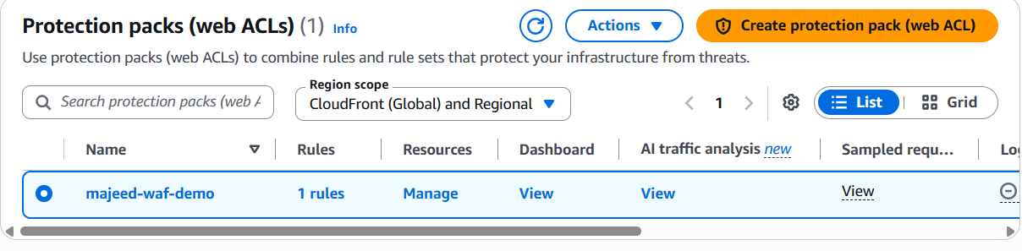
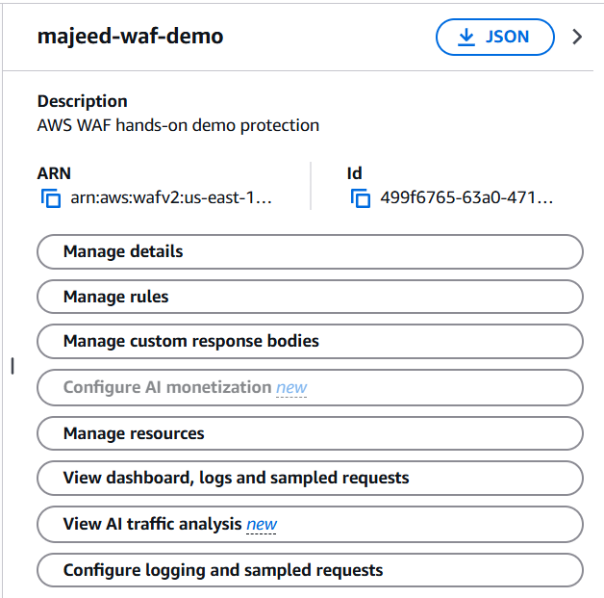

2: AWS Systems Manager Parameter Store
AWS Systems Manager Parameter Store is a service used to store and retrieve configuration values and parameters securely.
Objective
To understand and implement AWS Systems Manager Parameter Store for centralized storage and management of application configuration values.
Implementation / Steps
- Opened AWS Systems Manager → Parameter Store in the AWS Management Console.
- Clicked Create parameter.
- Created the parameter with the following configuration:
  - Name: /majeed/app/environment
  - Description: Application environment configuration for hands-on demo
  - Tier: Standard
  - Type: String
  - Value: development
  - Tags: None
- Clicked Create parameter.
- Verified that the parameter was successfully created and appeared under My parameters.
- Opened /majeed/app/environment and verified:
  - Type: String
  - Tier: Standard
  - Value: development
  - Version: 1
- Opened the History tab and verified Version 1 of the parameter.
- Confirmed that Parameter Store maintains parameter version history.
Result
The parameter /majeed/app/environment was successfully created and verified in AWS Systems Manager Parameter Store.
Observation
Parameter Store can be used to centrally store application configuration values instead of hardcoding them in application code. It also provides parameter version tracking.
Screenshots
- Create parameter configuration screen
- Parameter successfully created screen
- Parameter Overview showing the stored value
- Parameter History showing Version 1

